

Fof量化投资交易管理系统

**Quantitative Investment Transaction**

**Management System of FOF**

**软件测试报告书**



**System Test Report**

——2016届“花旗杯”金融创新应用大赛

Contents

1. The Introduction 4

1.1. The Intension of the report 4

1.2. Background 4

1.3. User Group 5

1.4. Term Definition 5

1.5. Test Object 6

1.6. Test Phase 6

1.7. Reference Material 6

2. The outline of the test 6

2.1. Test Enviroment 6

2.1.1. Hardware Environment 6

2.1.2. Software Environment 6

2.1.3. Network Topology 7

2.1.4. The Method and Tools of the Test 7

2.2. Test Purpose 8

2.3. Test Execution 8

2.4. Test Personnel and Test Time 8

2.4.1. Test Personnel 8

2.4.2. Test Time 8

3. Contents and Process of Unit Test 8

3.1. Unit Test Cases and Results 8

3.2. Analysis of Unit Test Results 20

3.2.1. Unit Test Process Summary 20

3.2.2. Summary of the Results of Testing Tasks 20

3.2.3. Defects and Differentiate 20

3.2.4. The Assessment of Product Quality 21

3.2.5. The Measurement Data 21

4. Content and Process of Integration Test 21

4.1. Integration Test cases and Results 21

4.2. Analysis of Integrate Test Results 26

4.2.1. Test Process Summary 26

4.2.2. Summary of Test Results 26

4.2.3. Defects and Differentiate 27

4.2.4. The Assessment of Produft Quality 27

4.2.5. The Measurement Data 27

5. Content and Process of System Test 28

5.1. Use-case of System Test 28

5.2. Test on System Function 28

5.2.1. Sign in of normal user and manager 28

5.2.2. View all the fund market information 28

5.2.3. View single fund’s specific information 29

5.2.4. Fund Searching according to a keyword 29

5.2.5. Generating new FOF combination 29

5.2.6. View main panel of FOF management 30

5.2.7. View realtime monitor information of the FOF 30

5.2.8. View profit and loss information of the FOF 30

5.2.9. View report statistics information of the FOF 30

5.2.10. View performance attribution information of the FOF 31

5.2.11. View asset allocation information of the FOF 31

5.2.12. View position alteration information of the FOF 31

5.2.13. View performance estimation information of the FOF 31

5.2.14. Adjust position 31

5.2.15. User information management 32

5.2.16. Modify const parameter information 32

5.2.17. View risk control information 32

5.3. System Usability Test 32

5.4. Results and Defects Analysis of System Testing 33

5.4.1. Summary of Test Results 33

5.4.2. Records and Analysis of Testing Results 33

5.4.3. Coverage Analysis of System Testing 54

6. Test Conclusion and Suggestion 55

6.1. Function 55

6.2. Ease of Use 55

6.3. Reliability 55

6.4. Compatibility 56

6.5. Security 56

# The Introduction

## The Intension of the report

There are several objectives for writing the test report.

1. Gain a general evaluation for the quality of the software by analyzing the result of the test;
2. Analyze the process, product, resources and the information of the test and provide a reference for subsequent software program;
3. Evaluate the implementation of the plan and reschedule the work;
4. Find the defects in the software system and provide some advice;
5. Analyzing the test result, we will decide whether the system meets the needs and the forecast of the customers.

## Background

FOF, the abbreviation of Fund of Funds, refers specifically to invest in other funds, FOF does not directly invest in stocks or bonds, and only in the extent of other funds, indirectly through the holders of other securities investment funds to hold stocks, bonds and other assets. FOF is new kinds of funds, which is combined with Innovation of funds product and marketing channels. FOF filters the funds through professional methods and helps investors optimize investment performance. In addition, FOF has greater flexibility in choosing investment objective, in a depressed or volatile market environment, FOF `s advantages are more obvious.

This project aims at bringing quantitative method in the selection of funds in FOF portfolio. According to the history data of funds, we can obtain each public fund`s rating and form fund pool. Secondly, we can use the market and correlative risk parameter to calculate the weights of equity funds and fixed income funds, construct FOF portfolio, show fund`s NPV and other market information to user by friendly interface, and provide FOF quantitative investment for systemic support.

The specific goals of this project are as follows:

Establishing an investment strategy database, informationizing the FOF investment. The project is designed with the index system of evaluating funds, regularly updating funds rankings, forming a fund pool, then combined with the strategy`s model, determining the fund portfolio, which efficiently and simply provides the users of FOF quantitative investment system for decision support, achieving FOF investment electronically.

Regularly monitoring the market, suggesting that risk, maximizing profit. According to market changes, the project`s system can periodically adjust fund pool and corresponding weights of each portfolio fund, meanwhile, set back line and stop line, which can tip risk and unusual products to users in a timely manner, achieving effectively control of risks.

Providing a full range of management system, users can customize FOF portfolio according to self-indexes. For the first time use, Users need to input the total asset index, risk parameters index and so on, then the system automatically generates FOF portfolio that meeting the requirements of users, and facilitates the transactions. The system also presents the user with position information, performance indicators, fund rating and other fund information, which makes it easy for users to view the market in time. In addition, the project also consists of system management and artificial adjustment function, namely, if market volatility is detected, the system automatically opens a position or increases position; if fund`s weight is negative, we can artificially set weights of 0, realizing the comprehensive management for FOF portfolio.

## User Group

Primary Audiences：

the project manager of our system

the product manager of our system

the project testers of our system

maintainer of our system

Other Audiences：

related personnel of our system

## Term Definition

1. First-order false:

Can't completely satisfy the system requirements, basic function not be fully implemented; or endanger personal safety

1. Second-order false:

Seriously affect the system requirements and the realization of the basic functions, and there is no correct way (reinstall or do not belong to the correct way to restart the software).

1. Third-order false：

Seriously affect system requirements or the realization of the basic functions, but there is a reasonable correction method (reinstall or do not belong to the correct way to restart the software).

1. Forth-order false：

Make the operator not convenient or in trouble, but it does not affect the work performed or important functions.

1. Fifth-order false：

Other problems

## Test Object

The quantitative investment transaction management system of FOF

## Test Phase

Unit testing

Integration testing

System testing

## Reference Material

《Software Requirements Specification》

《Prototype Iterations Document》

《Business Plan》

# The outline of the test



## Test Enviroment

### Hardware Environment

CPU：Intel® Core™ i3-6320 CPU @ 3.90GHz 3.90GHz

RAM：4.00 GB （3.85GB可用）

System Type：64 bit operating system，base on x64 CPU

### Software Environment

Database System：MySQL5.7.12

PC operating system：Windows8.1、Windows10

MCR(Matlab Compiler Runtime)：MCR8.5（R2015a）

### Network Topology

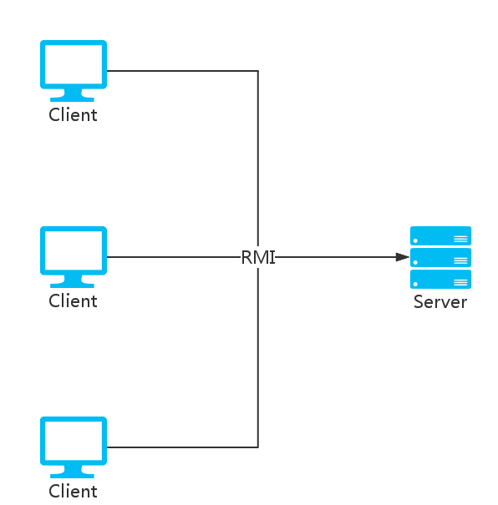

### The Method and Tools of the Test

Table 2.1.4-1 the method and tools of the test

|  |  |  |  |  |
| --- | --- | --- | --- | --- |
| Group standard | Category | Test method | Test tools | 备注 |
| Test object | Unit testing | The combination of Black box testing and White box testing Part of the testing use stub and driver. Use write box tesing for some important logic. Examined the code coverage rate. | Junit、Cobertura |  |
| Integration testing | CI | Jenkins |  |
| System testing | refer to the Software Requirements Specification to test | Random test |  |
| Test target | Function | Black box,manual |  |
| Performance | Black box,manual | test the time to processing service |
| Security | Black box,manual |  |

## Test Purpose

According to the software requirements specification，we find the deficiency andproblems of the system and verify whether the system meets the requirements specification. Additionally, we ensure that the system will meet the needs of customers in all respects before hand over, guarantee the reliability of the system and improve the quality of the software system.

## Test Execution

This test was carried out in accordance with the plan of project and test strictly and complete the test of planned target on time. During the test, we operated the test as the planned strategy rigidly. Additionally, the test group conducted the complete test for the system according to test plan and examples.

## Test Personnel and Test Time

### Test Personnel

Test engineer：Yanfei Yang

Test personnel：Xinyue Tan,Yanfei Yang

### Test Time

Begin：2016/09/05

End：2016/ 09/10

# Contents and Process of Unit Test



## Unit Test Cases and Results

|  |  |  |  |  |  |  |
| --- | --- | --- | --- | --- | --- | --- |
| ID | Name | Condition | Input | Expected  Result | Actual  Result | Remarks |
| Testcase001 | Calculate the profit rate value of alpha | / | the profit rate of China Growth(000001) and the Total Fund Index in 2015 | 0.1345 | 0.1345 |  |
| Testcase002 | Calculate the profit rate value of alpha | / | the profit rate of Huitianfu real debt A (000122) and the Total Fund Index in 2015 | 0.0708 | 0.0708 |  |
| Testcase003 | Calculate the profit rate value of beta | / | the profit rate of China Growth(000001) and the Total Fund Index in 2015 | 0.7157 | 0.7157 |  |
| Testcase004 | Calculate the profit rate value of beta | / | the profit rate of Huitianfu real debt A (000122) and the Total Fund Index in 2015 | 0.0233 | 0.0233 |  |
| Testcase005 | Calculate the profit rate value of sharpe | / | the profit rate of China Growth(000001) and the Total Fund Index in 2015 | -0.025 | -0.025 |  |
| Testcase006 | Calculate the profit rate value of sharpe | / | the profit rate of Huitianfu real debt A (000122) and the Total Fund Index in 2015 | 0.127 | 0.127 |  |
| Testcase007 | Calculate the profit rate value of treynor | / | the profit rate of China Growth(000001) and the Total Fund Index in 2015 | -0.123 | -0.123 |  |
| Testcase008 | Calculate the profit rate value of treynor | / | the profit rate of Huitianfu real debt A (000122) and the Total Fund Index in 2015 | 1.179 | 1.179 |  |
| Testcase009 | Calculate the profit rate value of Jensen | / | the profit rate of China Growth(000001) and the Total Fund Index in 2015 | 0.135 | 0.135 |  |
| Testcase010 | Calculate the profit rate value of Jensen | / | the profit rate of Huitianfu real debt A (000122) and the Total Fund Index in 2015 | 0.071 | 0.071 |  |
| Testcase011 | Calculate the average of profit rate | / | the profit rate of China Growth (000001) in 2015 | -0.021 | -0.021 |  |
| Testcase012 | Calculate the average of profit rate | / | the profit rate of Huitianfu real debt A (000122) in 2015 | 0.025 | 0.025 |  |
| Testcase013 | Calculate the standard deviation of profit rate | / | the profit rate of China Growth(000001) and the Total Fund Index in 2015 | 1.393 | 1.393 |  |
| Testcase014 | Calculate the standard deviation of profit rate | / | the profit rate of Huitianfu real debt A (000122) and the Total Fund Index in 2015 | 0.087 | 0.087 |  |
| Testcase015 | Calculate the year wave rate of profit rate | / | the profit rate of China Growth(000001) and the Total Fund Index in 2015 | 3.46 | 3.46 |  |
| Testcase016 | Calculate the year wave rate of profit rate | / | the profit rate of Huitianfu real debt A (000122) and the Total Fund Index in 2015 | 0.0233 | 0.0233 |  |
| Testcase017 | Calculate the profit rate index | / | the profit rate of Huitianfu real debt A (000122) in 2015 | 0.8  2.54  2.82  6.1  25.3  38.14  40.08  3.65  40.08  11.1 | 0.8  2.54  2.82  6.1  25.3  38.14  40.08  3.65  40.08  11.1 |  |
| Testcase018 | Calculate the profit rate index | / | the profit rate of China Growth(000001) and the Total Fund Index in 2015 | 1.37  3.67  5.31  -8.98  13.23  20.42  25.66  -17.47  485.54  14.58 | 1.37  3.67  5.31  -8.98  13.23  20.42  25.66  -17.47  485.54  14.58 |  |
| Testcase019 | get the history info of funds | / | 000001  UnitType.DAY  2016-03-01  2016-03-10 | 1.053,1.15  1.083,2.85  1.083,0.0  1.074,-0.83  1.083,0.84  1.083,0  1.074,-0.83  1.064,-0.93 | 1.053,1.15  1.083,2.85  1.083,0.0  1.074,-0.83  1.083,0.84  1.083,0  1.074,-0.83  1.064,-0.93 |  |
| Testcase020 | get the history info of funds | / | 000001  UnitType.WEEK  2016-03-01  2016-03-10 | 1.074,-0.2766  1.064,-0.927  1.105,3.8567 | 1.074,-0.2766  1.064,-0.927  1.105,3.8567 |  |
| Testcase021 | get the history info of funds | / | 000001  UnitType.WEEK  5 | 1.136，-0.09  1.134，-0.18  1.131，-0.26  1.133，-0.18  1.14，0.62 | 1.136，-0.09  1.134，-0.18  1.131，-0.26  1.133，-0.18  1.14，0.62 |  |
| Testcase022 | get the history info of funds to be shown in the chart | / | 000001  UnitType.DAY  TimeType.  ONE_MONTH  CharType.NET_  WORTH_  PROFORMANCE_  UNIT | 1.125,1.125,1.125  1.129,1.129,1.133  1.129,1.127,1.130  1.122,1.126,1.124  1.126,1.136,1.142  1.137,1.153,1.170  1.140,1.150,1.165  1.141,1.149,1.164 | 1.125,1.125,1.125  1.129,1.129,1.133  1.129,1.127,1.130  1.122,1.126,1.124  1.126,1.136,1.142  1.137,1.153,1.170  1.140,1.150,1.165  1.141,1.149,1.164 |  |
| Testcase023 | get the asset allocation of funds | / | 000001 | 29.39  52.3  14.17  14.1  25.2  7.94  1.64  2.9  51.27  56.16 | 29.39  52.3  14.17  14.1  25.2  7.94  1.64  2.9  51.27  56.16 |  |
| Testcase024 | get the stock allocation of funds | / | 000001  HoldingType.  STOCK | 002051，3.32  000876，2.0  002175，1.77  600804，1.46  600887，1.14  600521，1.13  000963，1.06  300156，0.96  002311，0.92  600056，0.9 | 002051，3.32  000876，2.0  002175，1.77  600804，1.46  600887，1.14  600521，1.13  000963，1.06  300156，0.96  002311，0.92  600056，0.9 |  |
| Testcase025 | get the industry allocation of funds | / | 000001  HoldingType.  INDUSTRY | C，32.39  I，4.37  E，4.53  F，3.03  K，2.51  D，2.46  B，2.32  R，1.45  J，0.97  G，0.74 | C，32.39  I，4.37  E，4.53  F，3.03  K，2.51  D，2.46  B，2.32  R，1.45  J，0.97  G，0.74 |  |
| Testcase026 | fund search | / | ‘大数据’ | 001113，大数据100；  001242，博时大数据100A  001243，南方大数据A  001420，南方大数据C  001564，东方红大数据  001637，嘉实腾讯自选股大数据策略股票  001734，广发百发大数据成长混合A  001735，广发百发大数据成长混合E  001741，广发百发大数据精选混合A  001742，广发百发大数据精选混合E  002263，泰达宏利大数据混  002269，银华大数据  002588，博时银智大数据100  519132，海富通东财大数据混合 | 001113，大数据100；  001242，博时大数据100A  001243，南方大数据A  001420，南方大数据C  001564，东方红大数据  001637，嘉实腾讯自选股大数据策略股票  001734，广发百发大数据成长混合A  001735，广发百发大数据成长混合E  001741，广发百发大数据精选混合A  001742，广发百发大数据精选混合E  002263，泰达宏利大数据混  002269，银华大数据  002588，博时银智大数据100  519132，海富通东财大数据混合 |  |
| Testcase027 | get the return statistics of funds | / | 2015-01-01  2016-09-06  UnitType.DAY  上证基金指数 | {238.0，172.0，0.0，410.0}、{58.05，41.95，0.0，100}  {0.46，-0.52，0.0，0.05}  {0.74，0.73，0.0，87.98}  {10.0，6.0，0.0，0.0}  {2.38，1.72，0.0,0.0}  {4.89，-1.8，-6.69，2015-07-08}  {4.71，-2.57，-7.27，2015-01-19}  {4.25，5.18，0.93，2016-06-04}  {-4.8，1.96，6.76，2015-07-09}  {-4.21，-1.04，3.17，2015-09-16}  {-3.77，1.86，5.63，2015-07-10} | {238.0，172.0，0.0，410.0}、{58.05，41.95，0.0，100}  {0.46，-0.52，0.0，0.05}  {0.74，0.73，0.0，87.98}  {10.0，6.0，0.0，0.0}  {2.38，1.72，0.0,0.0}  {4.89，-1.8，-6.69，2015-07-08}  {4.71，-2.57，-7.27，2015-01-19}  {4.25，5.18，0.93，2016-06-04}  {-4.8，1.96，6.76，2015-07-09}  {-4.21，-1.04，3.17，2015-09-16}  {-3.77，1.86，5.63，2015-07-10} |  |
| Testcase028 | get the profit analyse of FOF | / | TimeType.  ONE_MONTH | 0.83  -1.69  3  5  0  4  7  11  -22.43  0  0.16  0.01  0.94  0.28  0.24  0.46  0.31  0.88  1.36  0.28 | 0.83  -1.69  3  5  0  4  7  11  -22.43  0  0.16  0.01  0.94  0.28  0.24  0.46  0.31  0.88  1.36  0.28 |  |
| Testcase029 | get the profit analyse of FOF |  | TimeType.  ONE_YEAR | 10.38  3.32  0.02  6  8  -0.02  4  8  10.76  3.44  0  1.44  0.01  0.85  0.02  0.29  0.05  0.25  0.72  0.08  0.02 | 10.38  3.32  0.02  6  8  -0.02  4  8  10.76  3.44  0  1.44  0.01  0.85  0.02  0.29  0.05  0.25  0.72  0.08  0.02 |  |
| Testcase030 | get the newest weight of all funds in the FOF | / | / | 159910，5.74  165511，6.31  340006，5.4  050021，5.87  070023，5.68  000122，10.32  166008，8.93  092002，8.64  233005，11.77  000131，11.21 | 159910，5.74  165511，6.31  340006，5.4  050021，5.87  070023，5.68  000122，10.32  166008，8.93  092002，8.64  233005，11.77  000131，11.21 |  |
| Testcase031 | get the codes of all funds in the FOF | / | / | 050021  070023  159910  165511  340006  000122  000131  092002  166008  233005 | 000011  000012 | wrong return value |
| Testcase032 | get the performance attribution of FOF | / | / | 1.2326  567.9052  7.0  7.0  1.4397  567.9052  8.1761  6.3993  1.1769  16.813 | 1.2326  567.9052  7.0  7.0  1.4397  567.9052  8.1761  6.3993  1.1769  16.813 |  |
| Testcase033 | add user | coressponding user hasn’t existed in database | yyf  male  yyf  123456  MANAGER | return tips that add success, add corresponding user information in database | return tips that add success, add corresponding user information in database |  |
| Testcase034 | add user | coressponding user has existed in database | yyf  male  yyf  123456  MANAGER | return tips that user existed | return tips that user existed |  |
| Testcase035 | delete user | coressponding user has existed in database | yyf  male  yyf  123456  MANAGER | return tips that delete success, delete corresponding user information from database | return tips that delete success, delete corresponding user information from database |  |
| Testcase036 | delete user | coressponding user hasn’t existed in database | yyf  male  yyf  123456  MANAGER | return tips that user not found | return tips that user not found |  |
| Testcase037 | update user infomation | coressponding user has existed in database | yyf  male  yyf  123456  NORMAL | return tips that database update success, update user information in database | return tips that database update success, update user information in database |  |
| Testcase038 | update the net worth of funds | database table has established | / | return tips that database update success，update net worth of all funds in database | return tips that database update success，update net worth of all funds in database | caused by multithreading and concurrence |
| Testcase039 | update rank information of funds | fund information has existed in database | / | return tips that update success, add rank information of fund in database, and the rank is roughly the same as that in ChenXing. | return tips that update success, add rank information of fund in database, and the rank is different from that in ChenXing. | caused by data、algorithm |
| Testcase040 | get the runtime estimate net worth information of fund | / | 000001 | the net worth and the rise of the corresponding fund at present | the net worth and the rise of the corresponding fund at present |  |
| Testcase041 | get the history risk information of FOF | / | / | the history risk information | the history risk information |  |

## Analysis of Unit Test Results

### Unit Test Process Summary

Mainly using stub and driver to guide test process. Using stub to replace some database operation to make logic test more easier.The whole test process is smoothly，but there’s some repetition codes to make the process tedious and boring.Hope to find better tool to handle test.

### Summary of the Results of Testing Tasks

Ensure that all unit pass the test of automation method. That means it ensures the method has the system expected input/output and invariants.

### Defects and Differentiate

chart 3.2.3-1important defect analysis of the unit test

|  |  |  |  |  |
| --- | --- | --- | --- | --- |
| Module Name | Defect ID | Brief Description | The Result of Analysis | The Test Pass |
| Fund rating | 001 | the rating result is different from that in ChenXing | the difference between data source | Pass |
| Update net worth of the fund | 002 | the process is so slowly and update repeatly | caused by multithreading and concurrence | Pass |

chart 3.2.3-2residue on the unresolved issue list of the unit test

|  |  |  |  |  |
| --- | --- | --- | --- | --- |
| Module Name | Defect ID | Nature | Brief Description | Analysis of Reasons |
| None |  |  |  |  |

### The Assessment of Product Quality

1. Overview: All of the Unit test pass the automation test, and reach the expected target, what’s more, it has reached the basic implementation coverage of complex logic code.
2. Remarks：The Unit Test focus on FOF generation process and the calculationg of the main index.Other unimportant logic did not implement the complete coverage of codes and branchs
3. Conclusion: The quality has already reached the standards, so we can carry out the subsequent packaging installation work.

### The Measurement Data

1. Defect Metrics：defect number is two，5% of the whole test numbers，and they are roughly fixed after adjustments.
2. Coverage Metric：Using Maven Cobertura to handle this.The total coverage rate is 70% except some getter and setter method.Reaching the demand of normal project;

# Content and Process of Integration Test



## Integration Test cases and Results

|  |  |  |  |  |  |  |
| --- | --- | --- | --- | --- | --- | --- |
| ID | Name | Condition | Input | Expected  Result | Actual  Result | Remarks |
| Testcase001 | examine the username and password | RMI connection is valid, and there a user named yyf identified by 123456 in the database | yyf  123456 | return  UserInfo | return  UserInfo | / |
| Testcase002 | examine the username and password | RMI connection is valid, and there a user named yyf not identified by 000000 in the database | yyf  000000 | throw exceptio, return tips that password is wrong | throw exceptio, return tips that password is wrong | / |
| Testcase003 | examine the username and password | RMI connection is valid，there is no user named yyf in database | yyf  123456 | throw exception. return tips that user not found | throw exception. return tips that user not found | / |
| Testcase004 | add user | RMI connection is valid，there is no user named yyf in database | yyf  123456  Gender.MALE  MANAGER | return tips that user add success. Add user information in database | return tips that user add success. Add user information in database | / |
| Testcase005 | add user | RMI connection is valid，there is a user named yyf in database | yyf  123456  Gender.MALE  MANAGER | throw exception. return tips that user has existed | throw exception. return tips that user has existed | / |
| Testcase006 | modify user information | RMI connection is valid，there is a user named yyf in database | yyf  123456  Gender.MALE  NORMAL | return tips that user modify success. Modify user information in database | return tips that user modify success. Modify user information in database | / |
| Testcase007 | modify user informantion | RMI connection is valid，there is no user named yyf in database | yyf  123456  Gender.MALE  NORMAL | throw exception. return tips that user not found | throw exception. return tips that user not found | / |
| Testcase008 | generate new FOF combination | RMI connection is valid，there is no FOF combination in database | 10000000000  CPPI  中风险 | generate coressponding FOF combination and show back-test result | generate coressponding FOF combination and show back-test result | / |
| Testcase009 | generate new FOF combination | RMI connection is valid，there is no FOF combination in database | 10000000000  风险平价  自定义  0.9  2 | generate coressponding FOF combination and show back-test result | generate coressponding FOF combination and show back-test result | / |
| Testcase010 | get FOF realtime monitor information | RMI connection is valid，there is some FOF history data in database | / | the newest information of the funds in FOF combination | the newest information of the funds in FOF combination | / |
| Testcase010 | get FOF profit and loss information | RMI connection is valid，there is some FOF history data in database | 2015-01-05  2016-09-06  上证基金指数 | the profit and loss information and risk information of FOF combination in the coressponding period | the profit and loss information and risk information of FOF combination in the coressponding period | / |
| Testcase011 | get FOF report statistics information | RMI connection is valid，there is some FOF history data in database | 2016-01-01  2016-09-09  UnitType.DAY  上证基金指数 | the report stastics information of FOF combination in the coressponding period | the report stastics information of FOF combination in the coressponding period | / |
| Testcase012 | get FOF asset allocation information | RMI connection is valid，there is some FOF history data in database | / | the historical profit info and net worth of the funds in the FOF combination | the historical profit info and net worth of the funds in the FOF combination | / |
| Testcase013 | get FOF postion alteration information | RMI connection is valid，there is some FOF history data in database | / | the historical position alteration information, including manual and automatic alteration | the historical position alteration information, only including manual alteration | automatic alteration not add in the log |
| Testcase014 | get FOF risk profit index information of performance estimation | RMI connection is valid，there is some FOF history data in database | / | the risk profit index information of the funds in the FOF combination | the risk profit index information of the funds in the FOF combination | / |
| Testcase015 | get FOF invest type information of performance estimation | RMI connection is valid，there is some FOF history data in database | / | the invest type information of the funds in the FOF combination | the invest type information of the funds in the FOF combination | / |
| Testcase016 | get the classified information of all funds | RMI connection is valid，there is fund information in database | / | the classified information of all funds | the classified information of all funds | / |
| Testcase017 | get the realtime information of all funds | RMI connection is valid，there is fund information in database | / | the realtime information of all funds | the realtime information of all funds | / |
| Testcase019 | get historical unit net worth and total net worth information of funds | RMI connection is valid，there is fund information in database | 000001 | historical unit net worth and total net worth information of coressponding fund | historical unit net worth and total net worth information of coressponding fund | / |
| Testcase020 | get basic information of funds | RMI connection is valid，there is fund information in database | 000005 | basic information of coressponding fund | basic information of coressponding fund | 无 |
| Testcase021 | get asset allocation information of funds | RMI connection is valid，there is fund information in database | 000005 | asset allocation information of coressponding fund | asset allocation information of coressponding fund | 无 |
| Testcase022 | get performance estimation information of funds | RMI connection is valid，there is fund information in database | 000005 | performance estimation information of coressponding fund | performance estimation information of coressponding fund |  |
| Testcase023 | get Million wave chart information of funds | RMI connection is valid，there is fund information in database | 000005 | Million wave chart information of coressponding fund | Million wave chart information of coressponding fund |  |
| Testcase024 | get const parameter information | RMI connection is valid，there is const parameter information in database | / | const parameter information | const parameter information |  |
| Testcase025 | update const parameter information | RMI connection is valid，there is const parameter information in database | new const parameter inforamtion | return tips that update success, update const parameter in database | return tips that update success, update const parameter in database |  |
| Testcase026 | adjust position | RMI connection is valid，there is FOF information in database | correct position weight | return tips that adjust success, add new adjust request in database | return tips that adjust success, add new adjust request in database |  |
| Testcase027 | adjust position | RMI connection is valid，there is FOF information in database | wrong position weight(the sum of the weight bigger than 100%) | return tips that weight information is wrong, there no operation in database | return tips that weight information is wrong, there no operation in database |  |

## Analysis of Integrate Test Results

### Test Process Summary

At the end of the architecture design phase, we develop Stub and Driver for logic layer.Due to Hibernate framework, the code implement of data layer is simple, and there is small possibility of defects in data layer, so we didn’t completely develop stub for data layer. In the construction phase, the rest all adopt the top-down developing structure, after the development of each level, we use the Stub of the next level for maven build. Step by step, the lower level are integrated into the completed code.

### Summary of Test Results

Task 1：

Description：Integrate logic layer and data layer

Operation：To replace part using data layer stub with real code implement. Writing test code ,and use maven build to conduct integrate test.

Conclusion：pass，reach the demand

Problem：None。

Tase 2：

Description：Integrate user interface layer and logic layer

Operation：To replace stub used in user layer with real code implement, completing system integrate

Conclusion：pass，reach the demand

Problem：None。

### Defects and Differentiate

chart 4.2.3-1serious defect analysis of the integration test

|  |  |  |  |  |
| --- | --- | --- | --- | --- |
| Module Name | Defect ID | Brief Description | The Result of Analysis | The Test Pass |
| FOFAssetAllo  cation.Change  Postition | 013 | the return position alteration not including system automatic alteration | Do not add automatic alteration in system log | Fail->Pass |

chart 4.2.3-2 residue defects and unresolved issues list of the integration test

|  |  |  |  |  |
| --- | --- | --- | --- | --- |
| Module Name | Defect ID | Nature | Brief Description | Analysis Reasons |
| None |  |  |  |  |

### The Assessment of Produft Quality

1. Overview： We use Jenkins to conduct continuous integration in the integration process. We use stub to replace some class which is not implemented, and the stub will be replaced with implemented class eventually. The final build result is SUCCESS.
2. Remarks：Caused by the lack of a fixed server, some commit operation is not trigger integration test in the continuous integration process immediately, and did not fix this kind of defects immediately. But there no such big influence on the final result.
3. Conclusion：achieve expected target，pass the test。

### The Measurement Data

1. Defect metrics in integration test：

Serious defect：0

Common defect：1

No-impact defect：0

1. Coverage metric in integration test：

Number of tested module：2

Number of module：2

Coverage of module：100%

# Content and Process of System Test



## Use-case of System Test

System is adopting the method of equivalence class division and boundary value testing system test,, according to the specification, divided into the following equivalence class:

1. Sign in of normal user and manager
2. View all the fund market information
3. View single fund’s specific information
4. Fund Searching according to a keyword
5. Generating new FOF combination
6. View main panel of FOF management
7. View realtime monitor information of the FOF
8. View profit and loss information of the FOF
9. View report statistics information of the FOF

10、View performance attribution information of the FOF

11、View asset allocation information of the FOF

12、View position alteration information of the FOF

13、View performance estimation information of the FOF

14、User adjust position

15、User information management

16、Modify const parameter information

17、View risk control information

## Test on System Function

### Sign in of normal user and manager

Test method：

1. Input correct username and password, see the login result
2. Input not existed username, see the login result
3. Input correct username and wrong password, see the login result

### View all the fund market information

Test method：

1. Select market infomation，view the top list information
2. Select a single fund,view the net worth and profit trend
3. Select different fund class,view the update of the top list
4. Select different fund, different fund class, view the panel result
5. Double click a fund ,view the specific information of single fund
6. Remarks：The information need to compare with the data from authority (such as winde)

### View single fund’s specific information

Test method：

1. Select fund specific information panel, and view basic information, profit rate index, rank information, performance estimation, million wave chart. asset allocation of fund
2. In the area of asset allocation, select distribution, heavy position bond, heavy position stock, heavy position industry, and check the information is correct
3. Move the mouse into million wave chart, check the interaction information is correct
4. Remarks：The information need to compare with the data from authority (such as winde)

### Fund Searching according to a keyword

Test method：

1. Input the keyword in search box in different panel, check the return information of fund list is correct
2. Single Click one of the fund list, check the skipping to fund specific information panel is correct.
3. Repeat the operation above, check the result is correct

### Generating new FOF combination

Test method：

1. Input the correct total asset in preference setting, and choose strategy CPPI or risk parity. And choose high risk, middle risk, low risk or custom in strategy CPPI. After that, check the large class configuration, small class configuration, back-test result is correct. Input correct FOF combination name and click generate, check the feedback information is correct.
2. Attempt to input wrong total asset(such as negative, unrecognized characters), check the feedback information is correct.
3. Log out from the system in the middle of FOF generation, check the system feedback.
4. Skip to other panel in the middle of FOF generation, check the system feedback.
5. Remarks: Before different test plan, it’s necessary to delete generated FOF combination from database.

### View main panel of FOF management

Test method：

1. Select FOF management, check the basic information, item information, total profit information is correct.
2. Click the small item, check the skipping is correct.
3. Move the mouse to total profit chart, check the interaction is correct.

### View realtime monitor information of the FOF

Test method：

1. Select FOF real time monitor, check the information of funds in FOF is correct.
2. Select single fund, check corresponding net worth performance chart is correct.
3. Change the adjustment information, unit information, time period information, check the chart is correct.
4. Change the compare base, check the table information is correct.
5. Repeat and combine the operation above, check the system is normal.

### View profit and loss information of the FOF

Test method：

1. Select FOF profit and loss statistics, check the information of profit and risk index is correct.
2. Change the begin date and end date, check the information is correct.
3. Change the compare base, check the table information is correct.
4. Repeat and combine the operation above, check the system is normal

### View report statistics information of the FOF

Test method：

1. Select FOF report statistics, check the information of statistics and profit chart is correct.
2. Change the begin date , end date and statistics cycles, check the information is correct.
3. Change the compare base, check the table information is correct.
4. Move mouse into profit chart, check the interaction information is correct.
5. Repeat and combine the operation above, check the system is normal

### View performance attribution information of the FOF

Test method：

1. Select FOF performance attribution, check the information of chart and table is correct.
2. Change the begin date and end date, check the information is correct.
3. Change the compare base, check the table information is correct.
4. Repeat and combine the operation above, check the system is normal.

### View asset allocation information of the FOF

Test method：

1. Select FOF asset allocation, check the profit information, net worth performance chart of funds in FOF is correct.
2. Select single fund, check corresponding net worth chart is correct.
3. Change the adjustment information, unit information, time period information, check the chart is correct.
4. Repeat and combine the operation above, check the system is normal

### View position alteration information of the FOF

Test method：

1. Select FOF position alteration, check the historical position alteration of FOF is correct.

### View performance estimation information of the FOF

Test method：

1. Select FOF performance estimation, check the risk profit index of funds in FOF is correct.
2. Select invest type, check the invest type of funds in FOF is correct.
3. Repeat changing the two option, check system is correct.

### Adjust position

Test method：

1. Select adjust position of FOF, check the current weight of funds in FOF is correct.
2. Use the slider to adjust fund weight, check the slider and the information is correct.
3. Attempt to adjust a result which sum of weight less than 100%, check the feedback information.
4. Attempt to adjust a result which sum of weight more than 100%, check the feedback information

### User information management

Test method：

1. Select user information management, check the user information is correct.
2. Select add user, input new user information, and affirm add , check the system feedback information
3. Select add user, input a user existed in database, click affirm add, check the system feedback information
4. Select modify user, modify existed user information , affirm modify , check the system feedback information
5. Select delete user, delete existed user, affirm delete, check the system feedback information
6. Repeat and combine the operation above, check the system is normal

### Modify const parameter information

Test method：

1. Select parameter modify function, check the parameter information is correct.
2. Modify one or more parameters, click confirm update, check system feedback information.

### View risk control information

Test method：

1. Select risk control function, check the chart information is correct.

## System Usability Test

Overview：For all system test cases, using the same system usability testing method.

Test Focus：The accuracy, consistency, intelligibility of operational options and tips information; the ailability and easy of use of shortcuts key used in some cases

Test method：Check each button and other operational option, check the display information and tips information; test the complexity and understandability of operation process.

## Results and Defects Analysis of System Testing



### Summary of Test Results

Total error distribution

|  |  |  |  |  |
| --- | --- | --- | --- | --- |
| Error Type | Error Number | Modified Error Number | Modifying Ratio | Percentage of Total Error Ratio |
| First-level error | 0 | 0 | / | / |
| Second-level error | 0 | 0 | / | / |
| Third-level error | 2 | 2 | 100% | 67% |
| Fourth-level error | 1 | 1 | 100% | 33% |
| Fifth-level error | 0 | 0 | / | / |
| Errors in Total | 3 | 3 | 100% | 100% |

### Records and Analysis of Testing Results

#### Sign in of normal user and manager

1. Input correct username and password, see the login result



1. Input not existed username, see the login result



1. Input correct username and wrong password, see the login result



#### View all the fund market information

1. Select market infomation，view the top list information

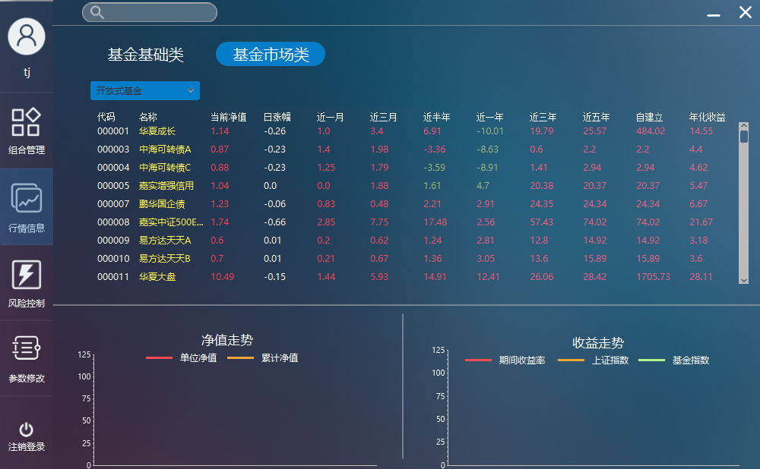

1. Select a single fund,view the net worth and profit trend

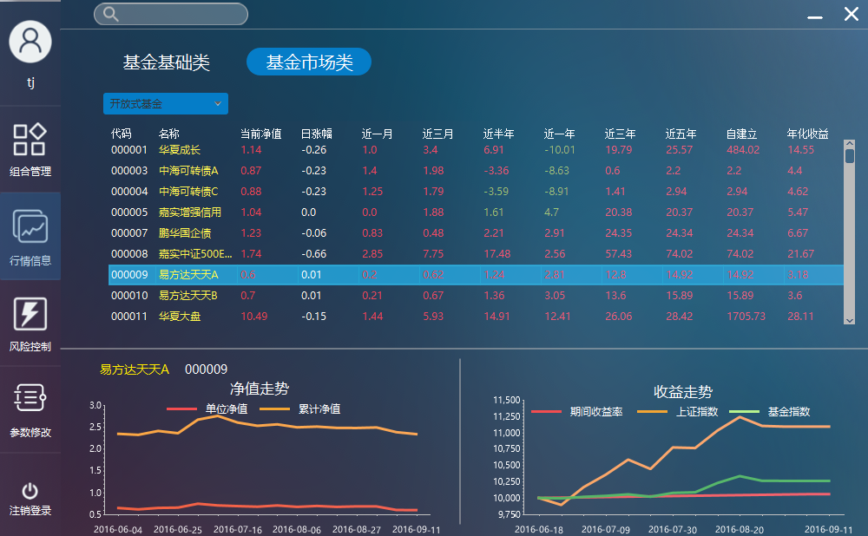

1. Select different fund class,view the update of the top list

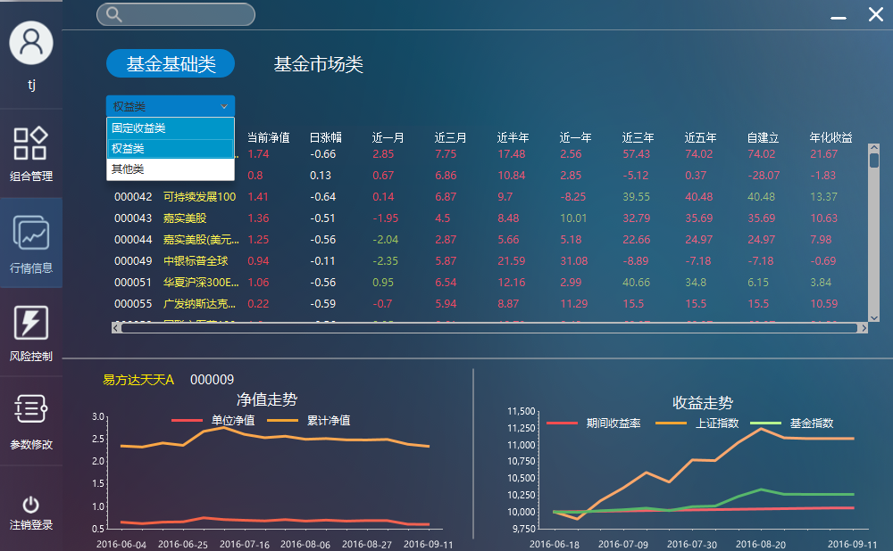

1. Double click a fund ,view the specific information of single fund

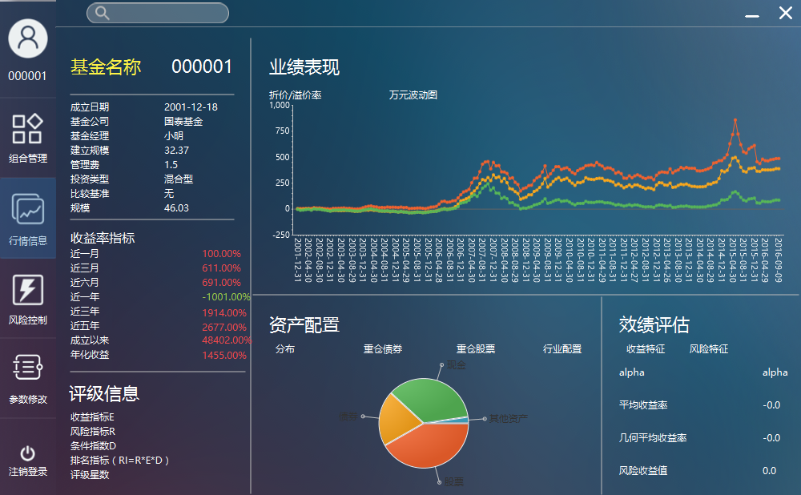

#### View single fund’s specific information

1. Select fund specific information panel, and view basic information, profit rate index, rank information, performance estimation, million wave chart. asset allocation of fund



1. In the area of asset allocation, select distribution, heavy position bond, heavy position stock, heavy position industry, and check the information is correct

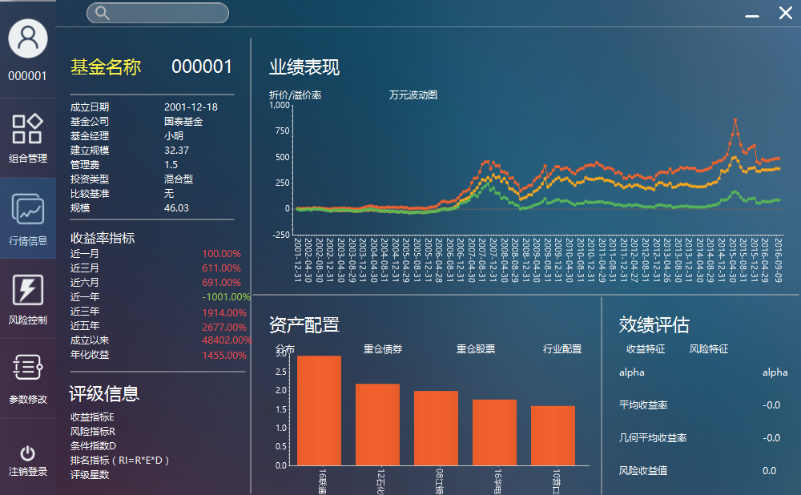

#### Fund Searching according to a keyword

1. Input the keyword in search box in different panel, check the return information of fund list is correct

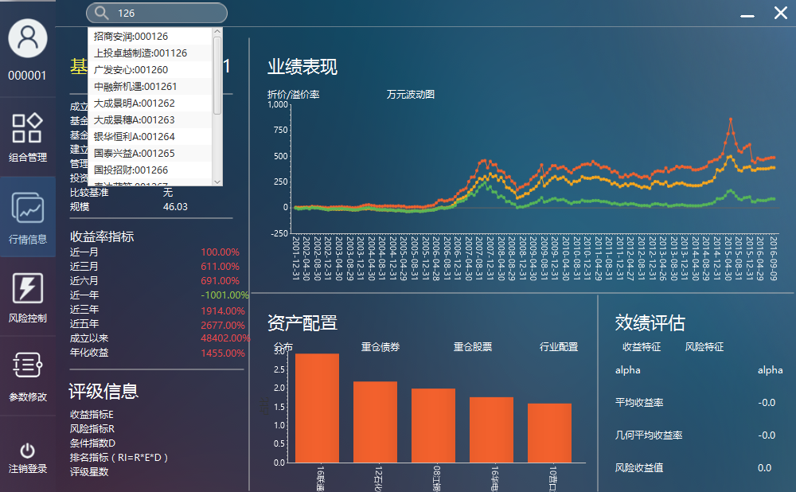

1. Single Click one of the fund list, check the skipping to fund specific information panel is correct

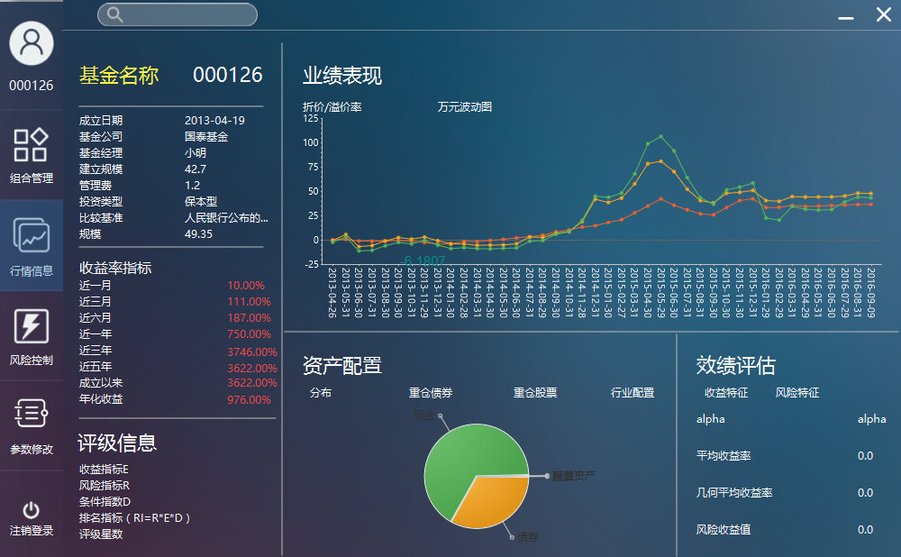

#### Generating new FOF combination

1. Input the correct total asset in preference setting, and choose strategy CPPI or risk parity. And choose high risk, middle risk, low risk or custom in strategy CPPI. After that, check the large class configuration, small class configuration, back-test result is correct. Input correct FOF combination name and click generate, check the feedback information is correct

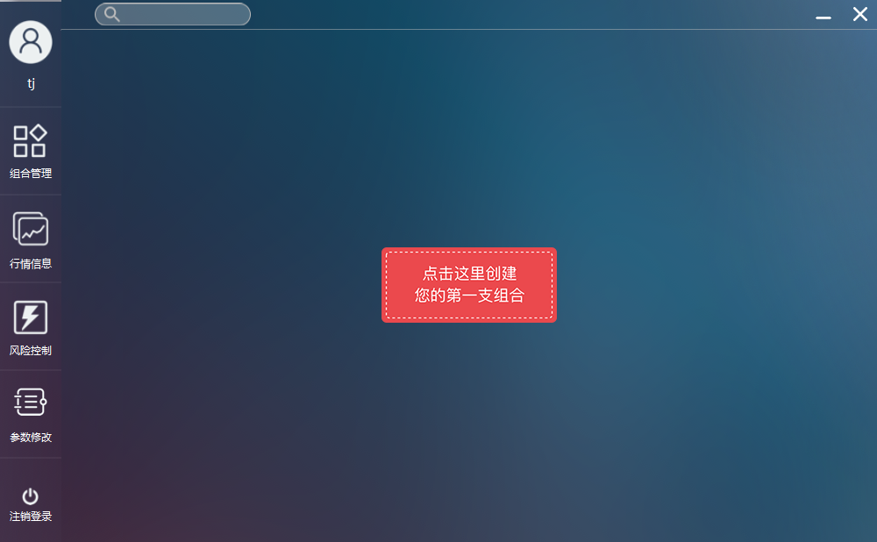

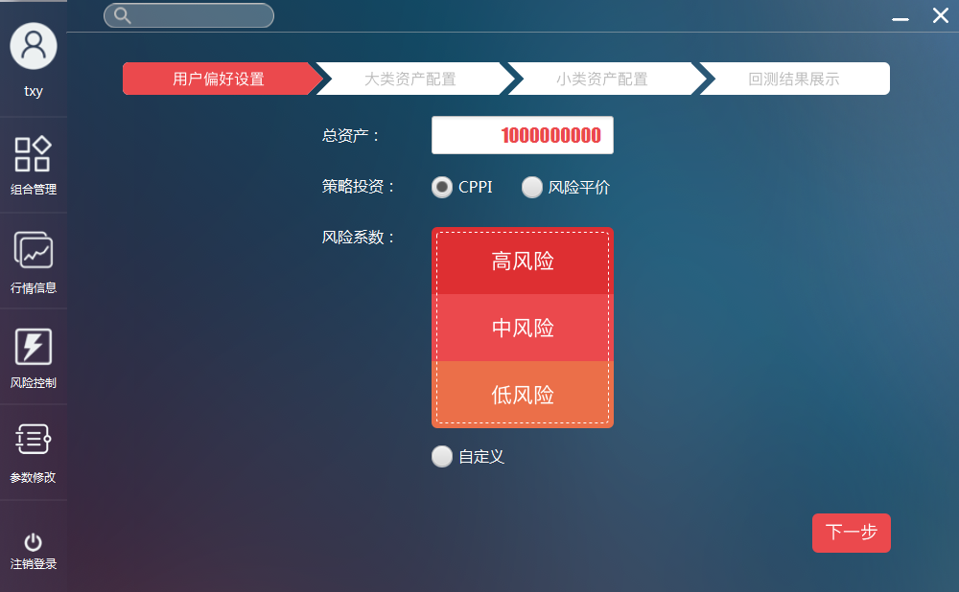

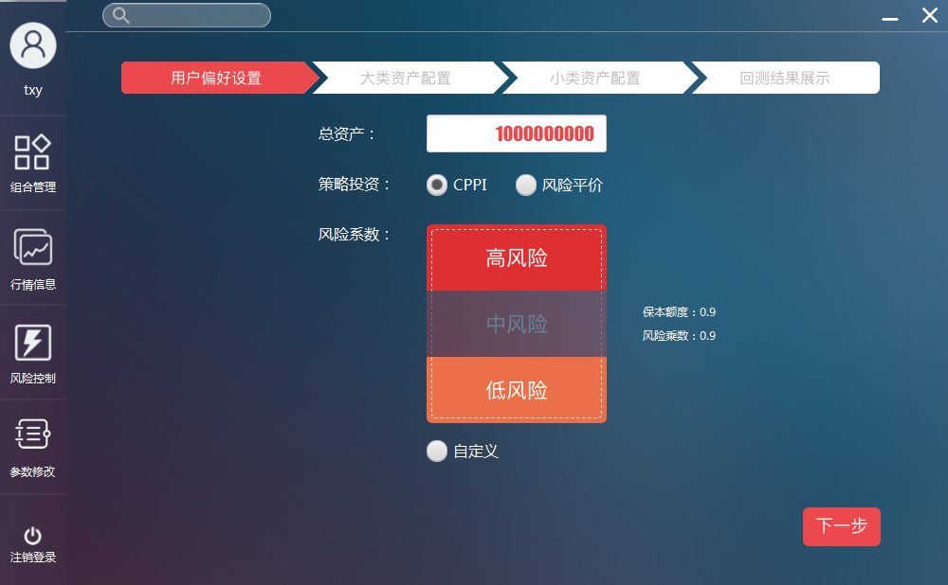

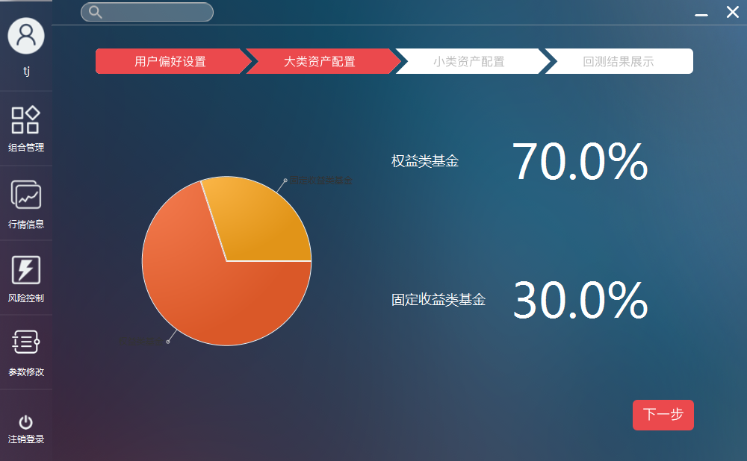

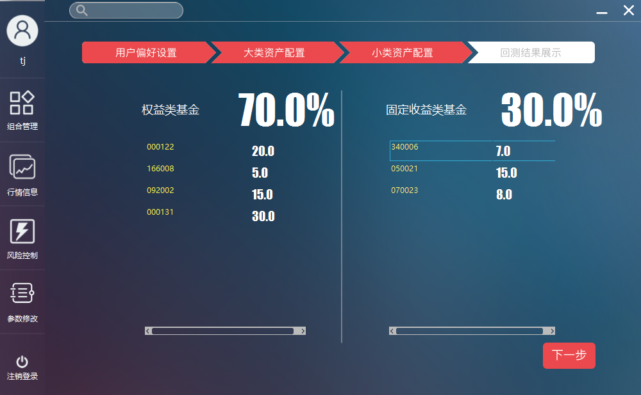

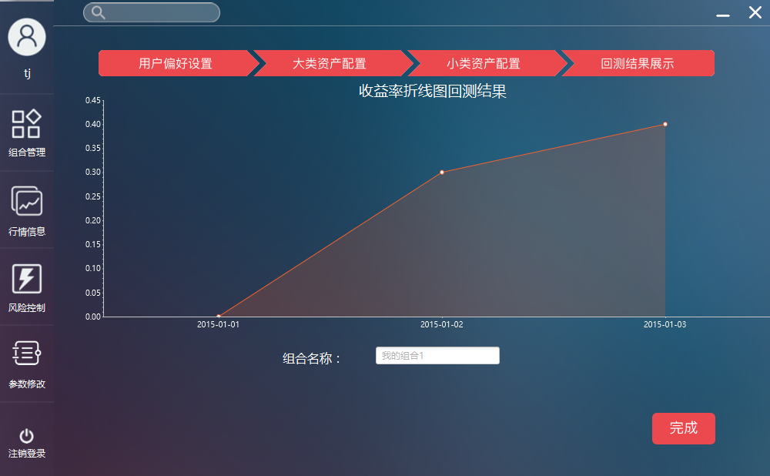

#### Generating new FOF combination

1. Select FOF management, check the basic information, item information, total profit information is correct

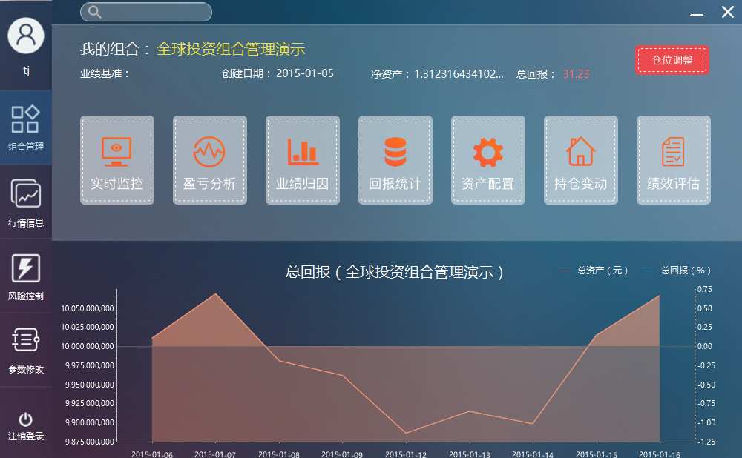

#### View realtime monitor information of the FOF

1. Select FOF real time monitor, check the information of funds in FOF is correct

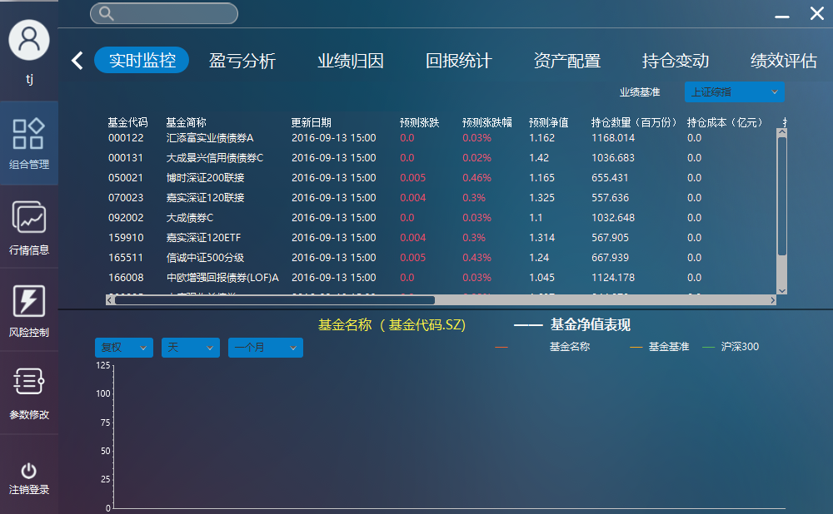

1. Select single fund, check corresponding net worth performance chart is correct

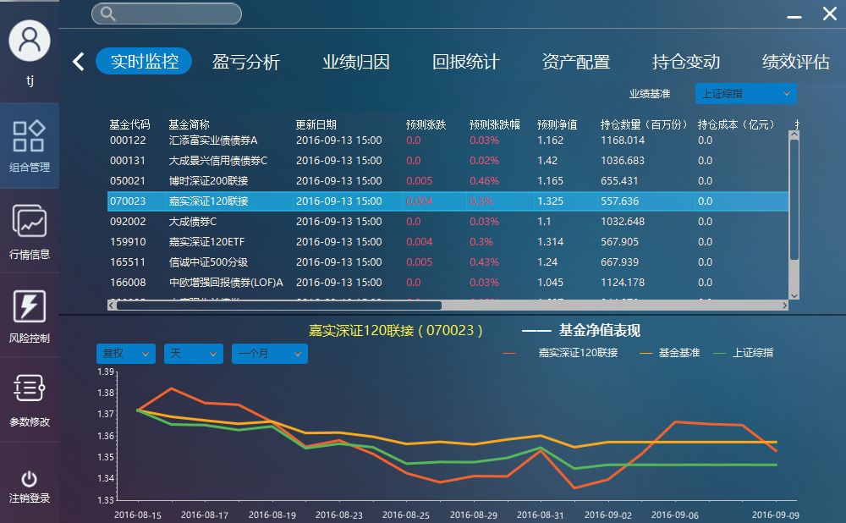

1. Change the adjustment information, unit information, time period information, check the chart is correct

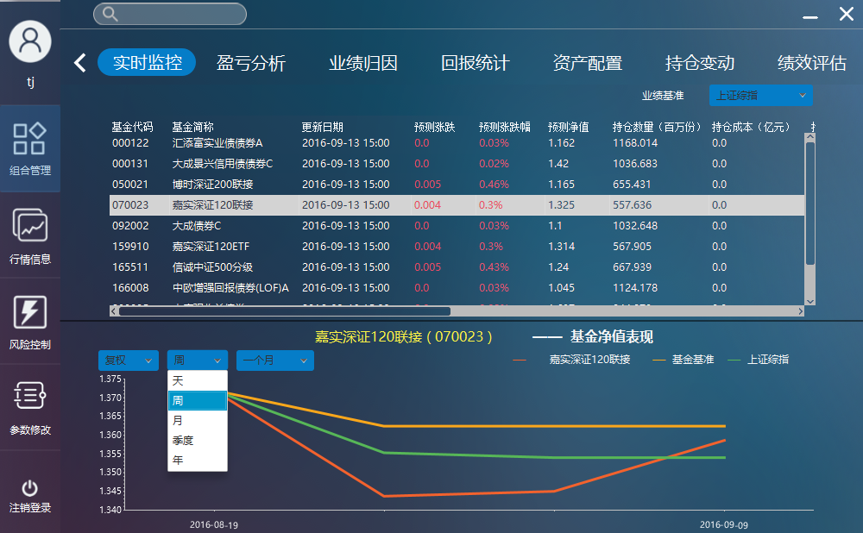

1. Change the compare base, check the table information is correct

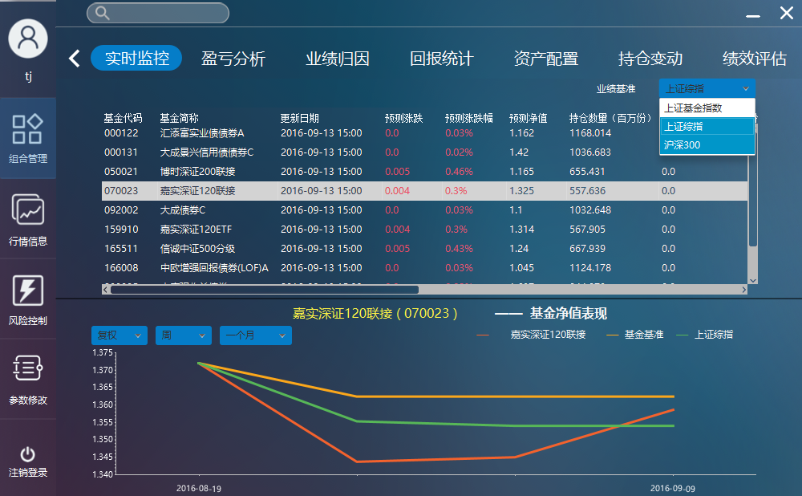

#### View profit and loss information of the FOF

1. Select FOF profit and loss statistics, check the information of profit and risk index is correct

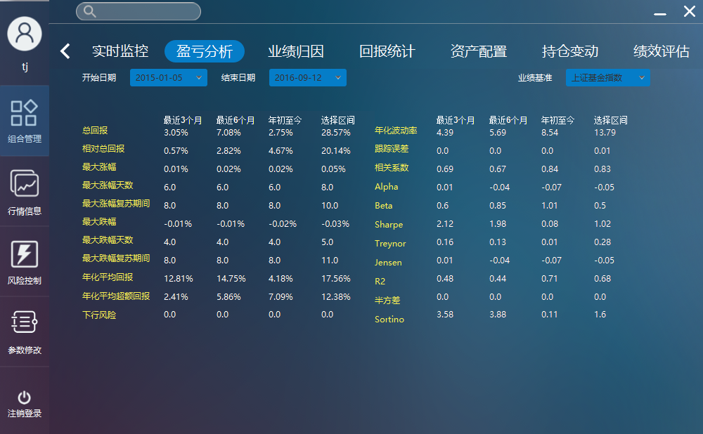

1. Change the begin date and end date, check the information is correct

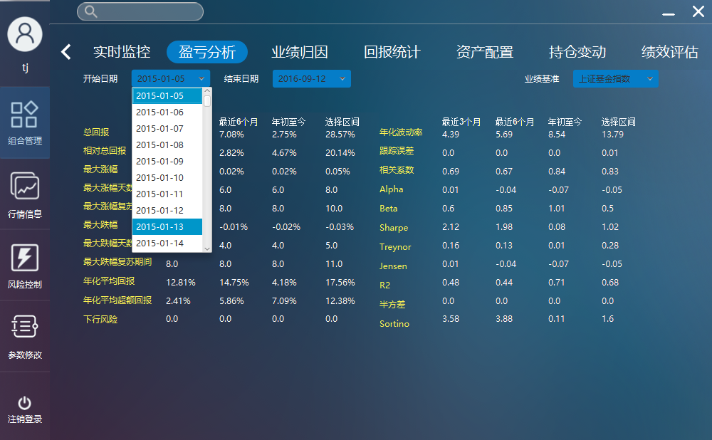

1. Change the compare base, check the table information is correct

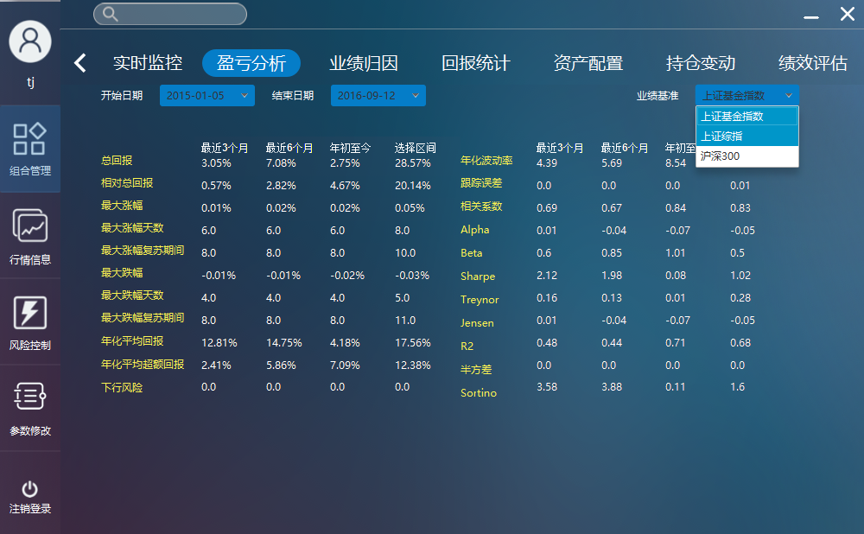

#### View report statistics information of the FOF

1. Select FOF report statistics, check the information of statistics and profit chart is correct

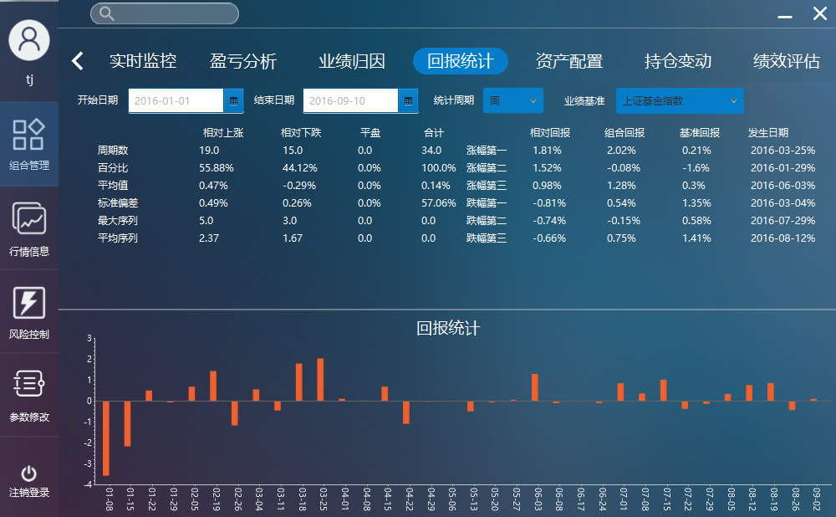

1. Change the begin date , end date and statistics cycles, check the information is correct

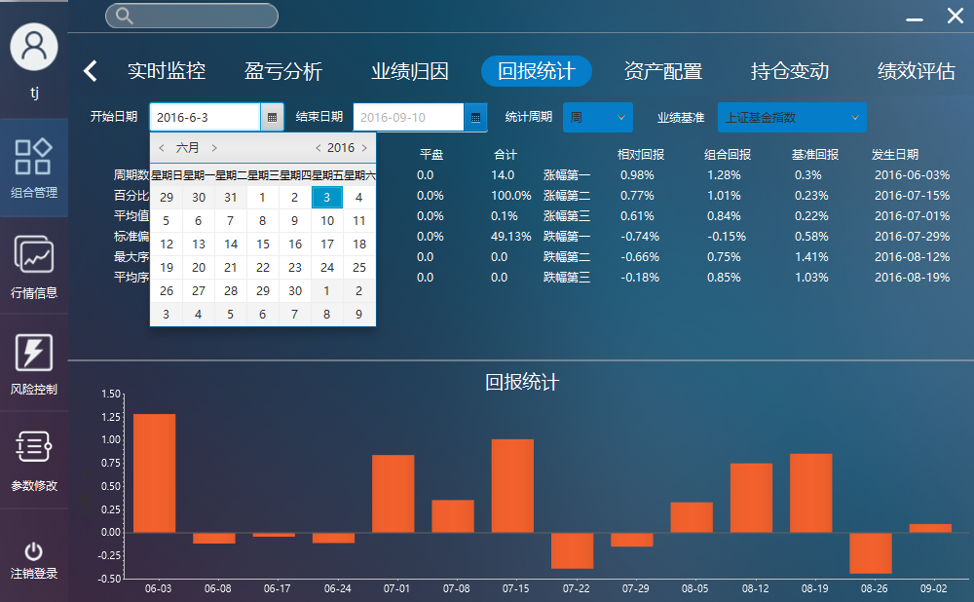

1. Change the compare base, check the table information is correct

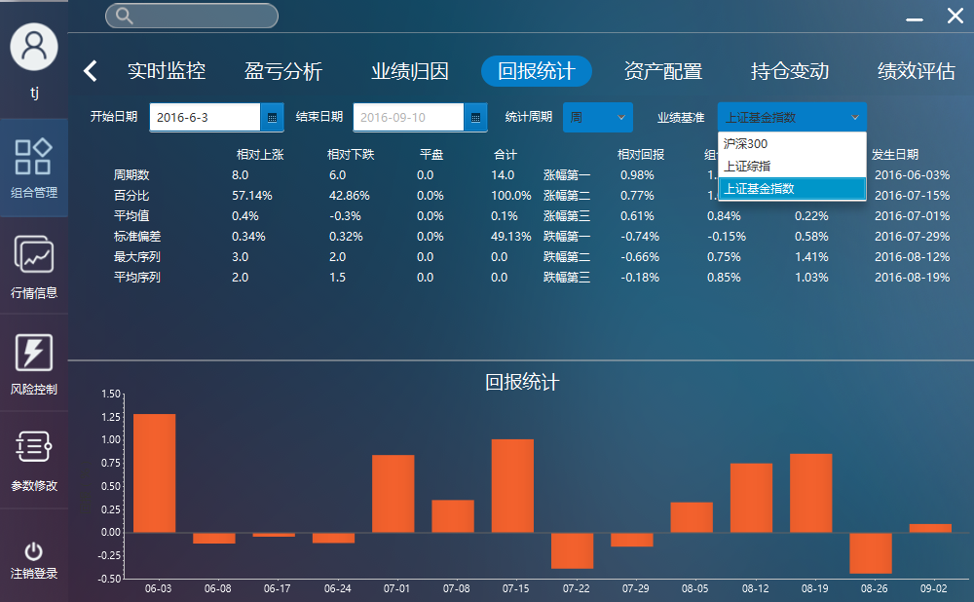

#### View report statistics information of the FOF

1. Select FOF performance attribution, check the information of chart and table is correct

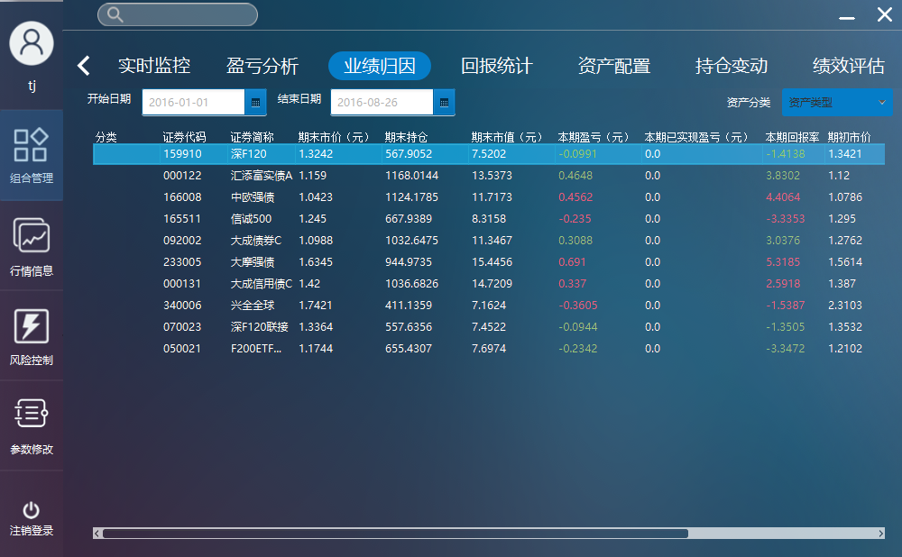

1. Change the begin date and end date, check the information is correct

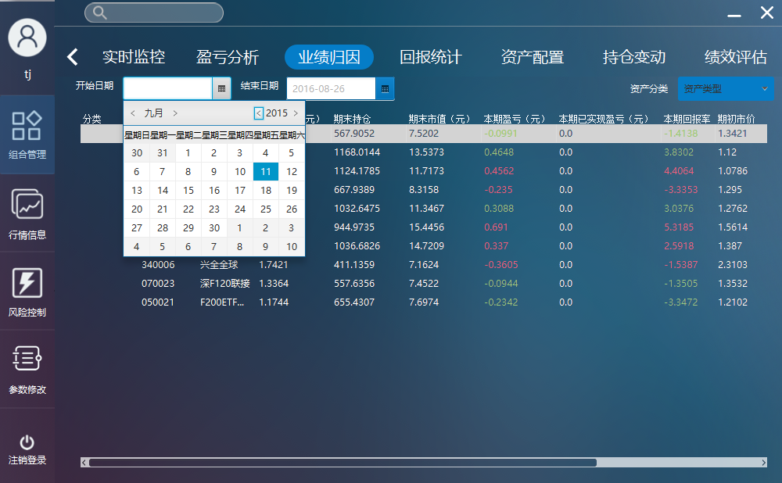

1. Change the compare base, check the table information is correct

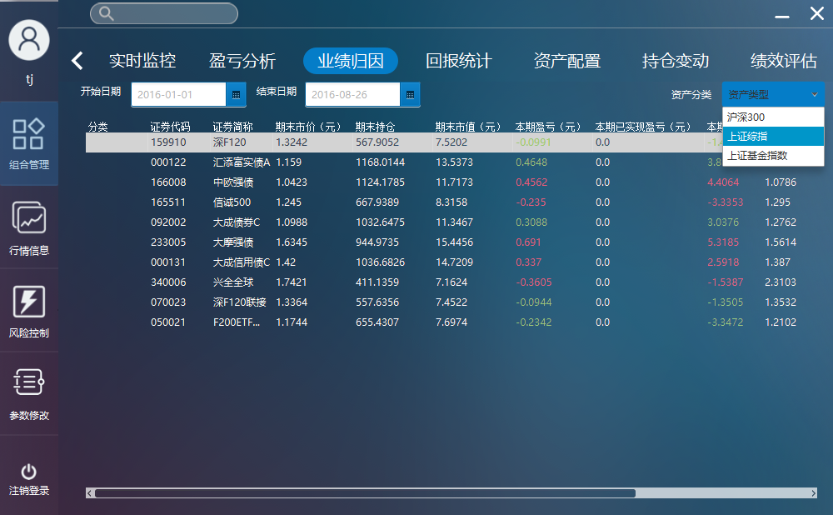

#### View asset allocation information of the FOF

1. Select FOF asset allocation, check the profit information, net worth performance chart of funds in FOF is correct

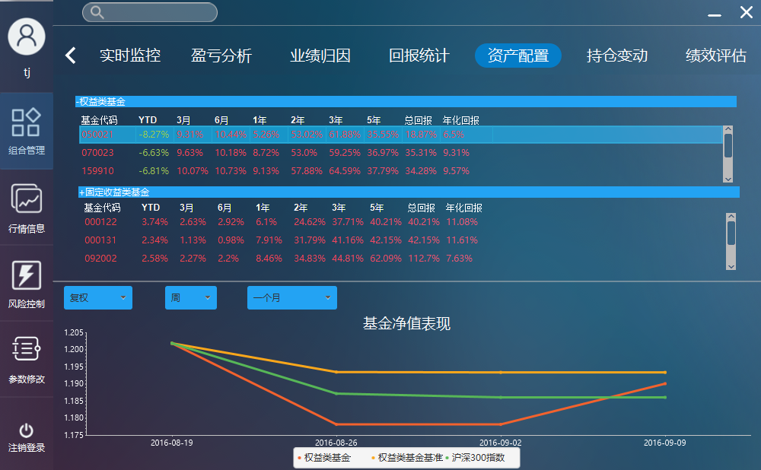

1. Select single fund, check corresponding net worth chart is correct

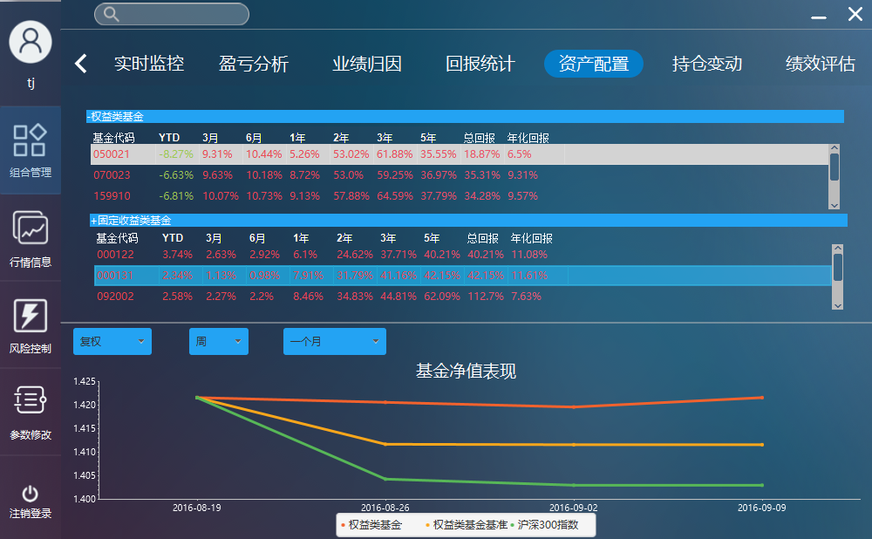

1. Change the adjustment information, unit information, time period information, check the chart is correct

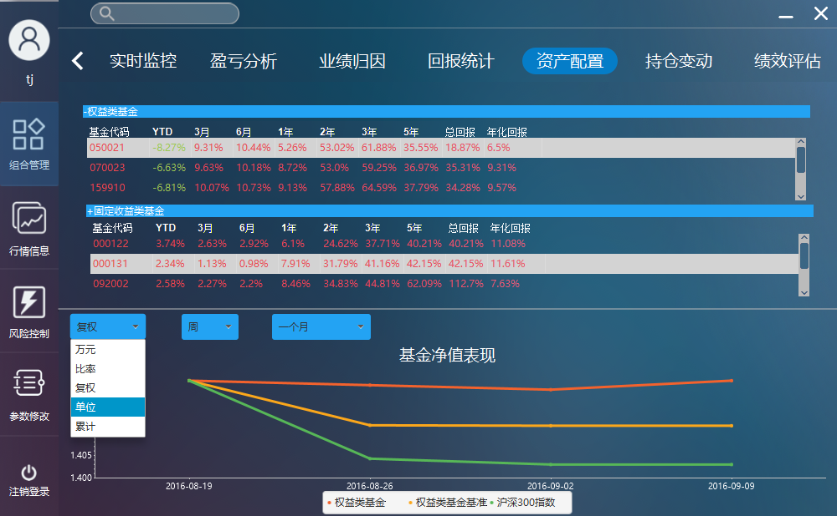

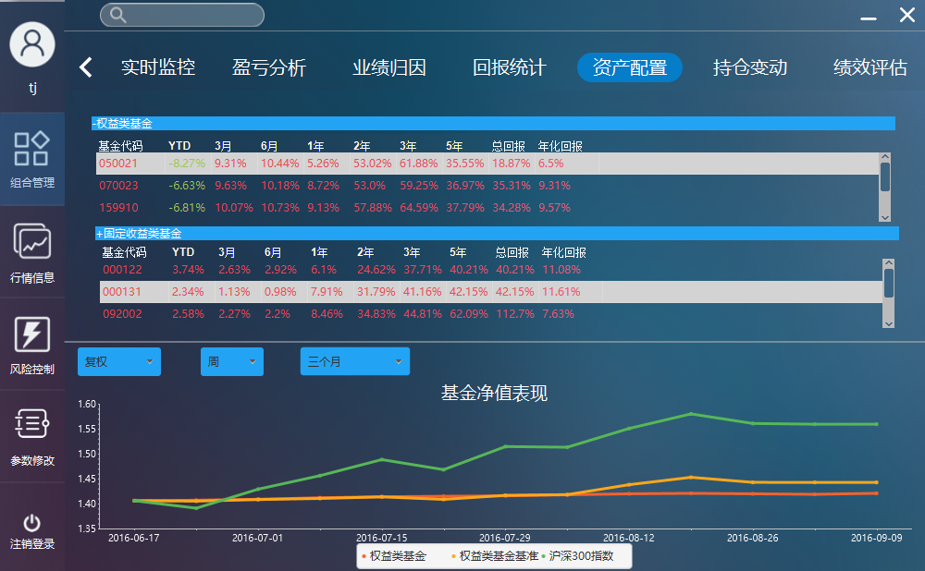

#### View position alteration information of the FOF

1. Select FOF position alteration, check the historical position alteration of FOF is correct

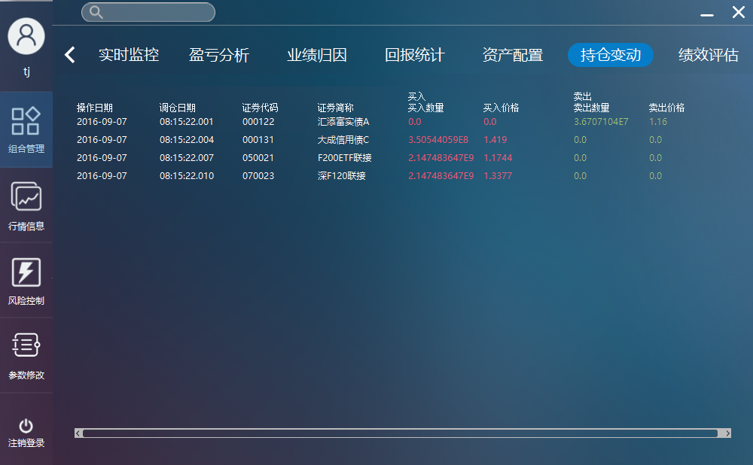

#### View performance estimation information of the FOF

1. Select FOF performance estimation, check the risk profit index of funds in FOF is correct.

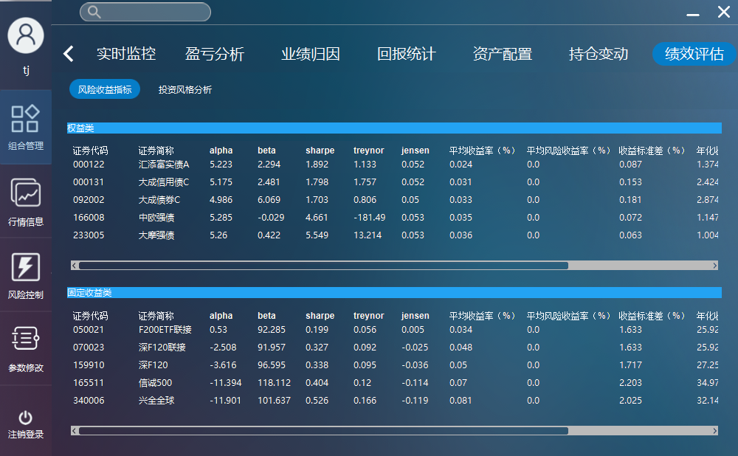

#### Adjust position

1. Select adjust position of FOF, check the current weight of funds in FOF is correct

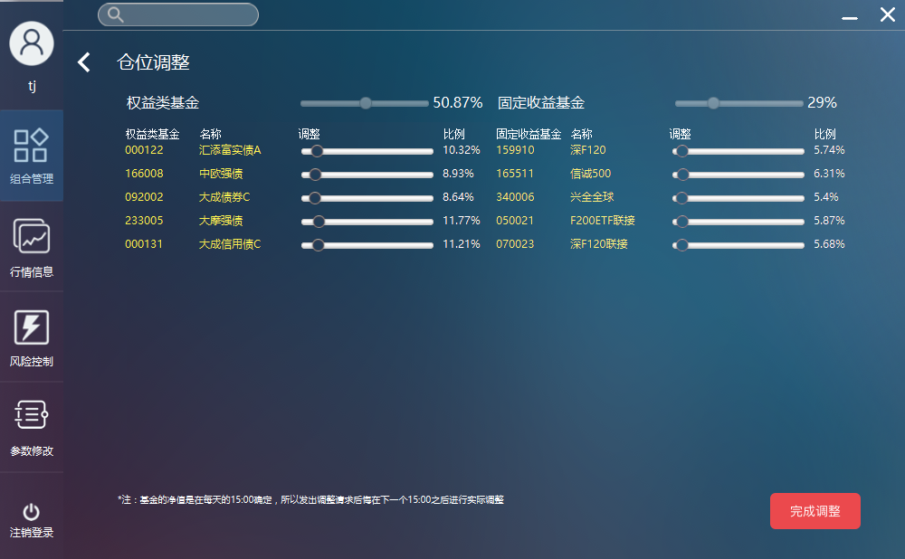

1. Use the slider to adjust fund weight, check the slider and the information is correct

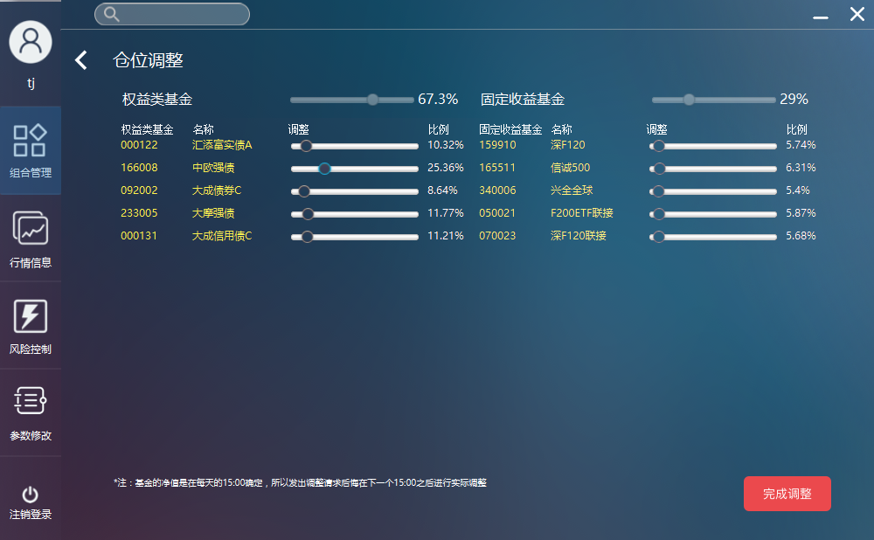

#### User information management

1. Select user information management, check the user information is correct.
2. Select add user, input new user information, and affirm add , check the system feedback information
3. Select add user, input a user existed in database, click affirm add, check the system feedback information
4. Select modify user, modify existed user information , affirm modify , check the system feedback information
5. Select delete user, delete existed user, affirm delete, check the system feedback information
6. Repeat and combine the operation above, check the system is normal

#### Modify const parameter information

1. Select parameter modify function, check the parameter information is correct

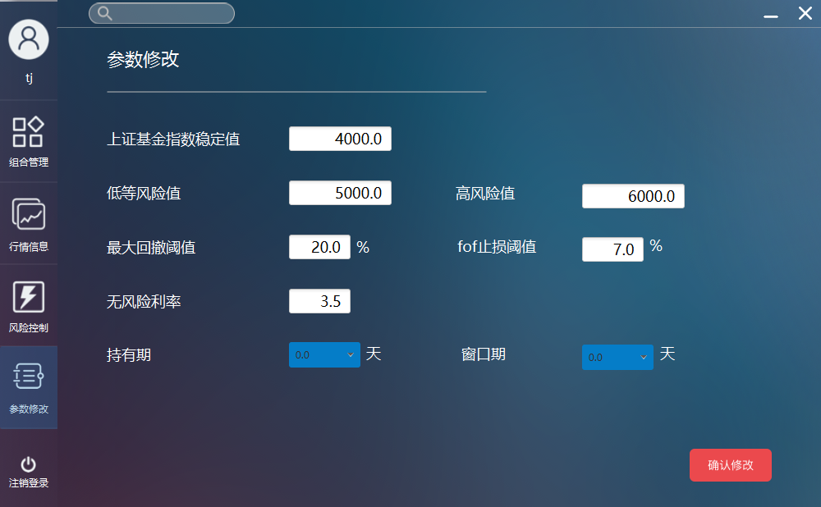

1. Modify one or more parameters, click confirm update, check system feedback information

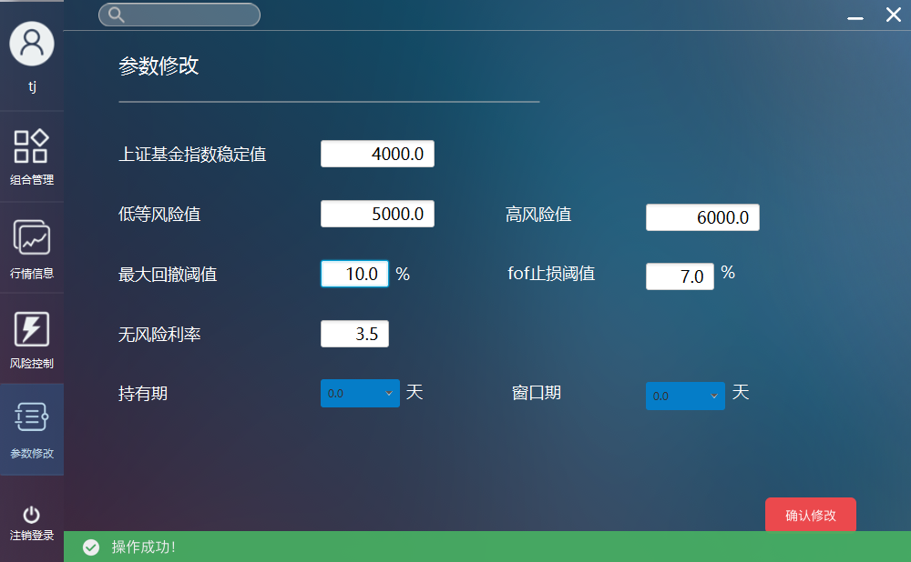

#### View risk control information

1、Select risk control function, check the chart information is correct

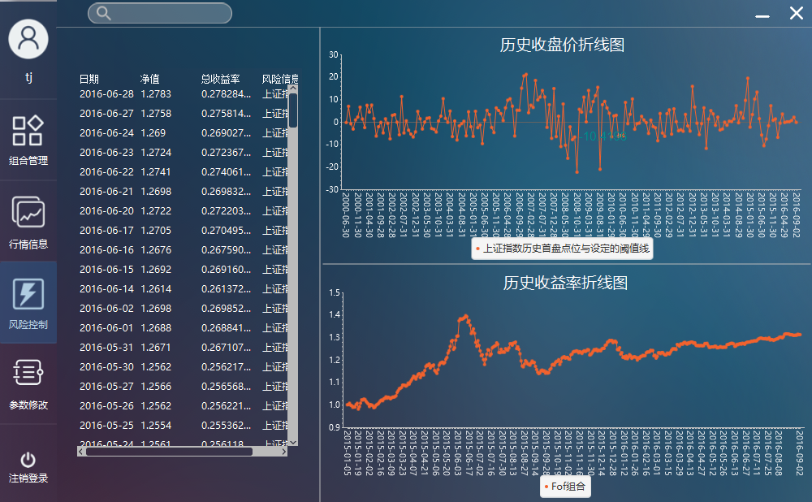

### Coverage Analysis of System Testing

According to Software Requirements Specification, implement 90% of the cover for the realization of the function involved in the document. But part of the description of the page needs no clear definition of the input limit without detailed definition, so there is no clear basis for testing. During the test, the test is based on the meaning of the input field, the test personnel understanding, and the project manager, the development of personnel communication to obtain the test basis, cannot guarantee the correctness and completeness of the test basis. As a result, the project team did not have a complete and correct invalid data test, the system test coverage is still not enough, cannot guarantee the validity and correctness of the test.

# Test Conclusion and Suggestion



## Function

System functions to achieve more than 90%, some of the details of the functional requirements failed to achieve. Reach the demand of normal project.

## Ease of Use

The existing system can achieve the following ease of use:

1. The correctness, understandability and consistency of tips information of wrong inpu.
2. The accuracy and validity of help information
3. User can get timely correction when errors occurred.
4. The consistency of system panel, style and operation.
5. The effectiveness and timeliness of system feedback information

The existing system has follow ease of use defects:

1. Part of the interface layout is not beautiful
2. Part of the interface is too slow

## Reliability

The reliability control of the existing system is basically up to the standard, because there is no excessive user data upload request, there is no big risk.

The existing system has a certain fault tolerance ability, when the system error occurs, most of the errors can be corrected, but some errors cannot be corrected in time.

Existing customers have a certain amount of concurrency, the customer is not very large, the client and server has a good concurrency

## Compatibility

The existing system based on the Java virtual machine running, theoretically support all the operating system can be installed Java virtual machine.The project team made the compatibility test of Windows8.1 and Windows10 system, which performed well.

## Security

The existing systems control the following security issues:

1. Usename and password is case sensitive.
2. Data encryption while transmission and storage(especially for the password transmission and storage)
3. Carry on the data backup periodically, make sure the important data can be retained and system can recovery as soon as possible when accident happends.

The existing systems do not control the following security issues:

1. Login error limitation
2. Do not carry on complete concurrent test, there may by problems in concurrent.